SKA Head receives honorary doctorate
27 March 2013
Wits University has conferred an honorary doctorate on Dr Bernie Fanaroff, Project Director of South Africa’s Square Kilometre Array bid and the construction of the Karoo Array Telescope, part of the University’s annual March graduations.
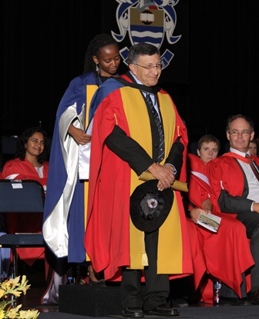Fanaroff's academic and professional career started when he was awarded a BSc Hons in Theoretical Physics from the University of the Witwatersrand. Building on this foundation he went on to complete a PhD in Radio Astronomy and Astrophysics at the University of Cambridge. He also holds an LLD (Honoris Causa) from Rhodes University and a D Phil (Honoris Causa) from the University of the Western Cape. He is a Visiting Professor in Physics at Oxford University.
In the 1980s, Fanaroff played a pivotal role in the trade union movement. In 2003 he was appointed as project director of the SA’s SKA bid that successfully resulted in South Africa being awarded the largest share of the SKA - the world's most powerful radio telescope.
In his address, Fanaroff thanked the graduands for choosing science as a study and career path.
“A degree in science gives you more than a knowledge of science. It also gives you the skill and confidence to solve problems, not only problems in your own field, but in the wider world. It gives you the ability to learn quickly and to understand how systems work. It gives you the skill and the confidence to be innovative, not only in science, but in whatever you do. These are qualities which are in short supply in South Africa, as they are in many other countries,” Fanaroff said.
He also addressed youth unemployment, calling it “our most urgent problem” and an increasing problem around the world, in both the developed and the developing world.
“One of the reasons is that the nature of employment is changing. Whether we like it or not, educated and skilled people are more likely to get work in the modern economy. We are deluding ourselves if we think that everyone can start a small business, especially without education and skills. Countries can become wealthy because they have abundant oil or gas or gold or iron ore, but even those countries need an educated and skilled population for sustainable growth.”
He continued: “I think that the most important challenge still facing us after 19 years of democracy is to establish a successful basic education system. We tried to do too many things and to make too many changes too quickly. We added to the problems of the schools by abolishing teacher training colleges, nursing colleges and technikons and by weakening the artisan training system. The result is that we have too few highly skilled technicians and artisans, and too few highly skilled and capable teachers, nurses and police. We have far too few engineers and scientists and too few doctors.”
Read the citation
Read Fanaroff’s address

